Github

1. Create a Git account – Go to www.github.com
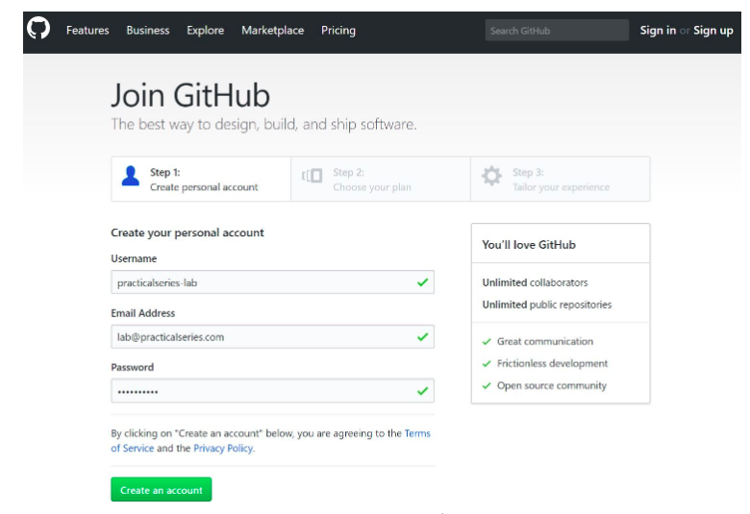

2. Created a new repository -

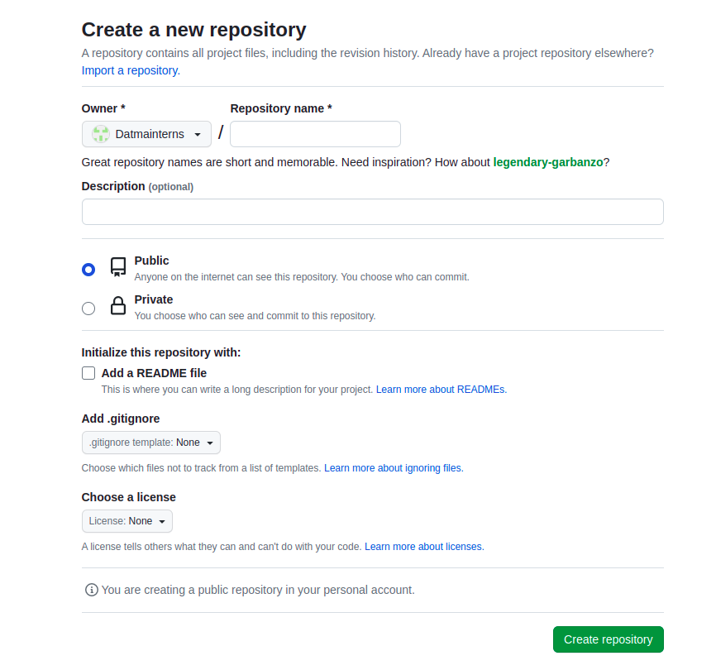

3. Added files to repository -

By doing this steps we can push our files from local system to Repo

* git init

* git add <file_name>

* git commit -m “<Commit_message>”

* git remote add <name> <URL>

* git branch -M main

* git push -u main

4. My repository with added files -

I have added multiple files using previous method, we can add files as well as directories
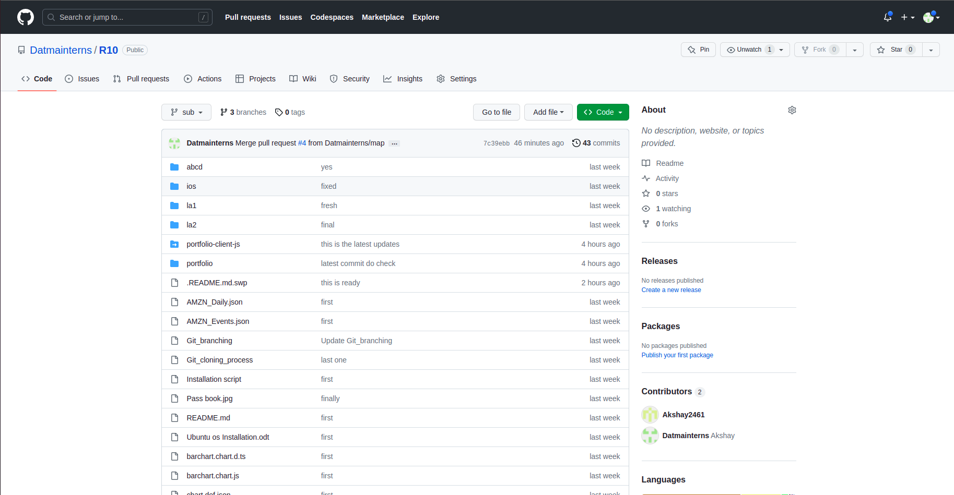

5. Cloning files from Repo to local -
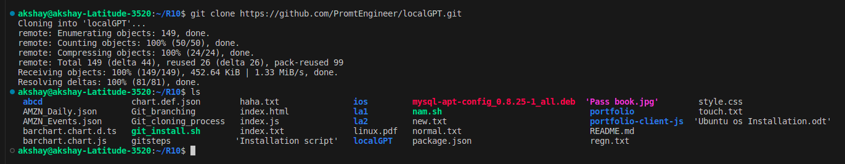
In this, I have cloned content from a Public repo to my local system
by this command
Command : git clone <URL>
This creates a copy of files to our local system

6. Pushing files to Repo -
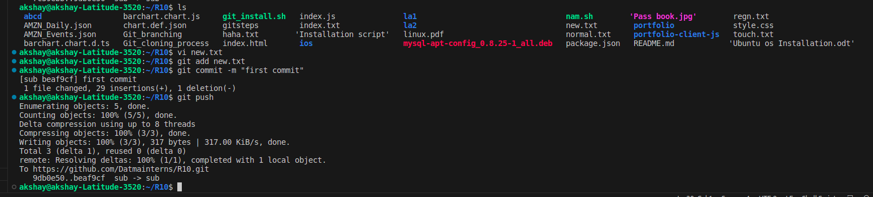
In this, I have pushed my updated files to repo
Firstly- edited some file (new.txt)
then, git add new.txt
git commit -m “first commit”
git push

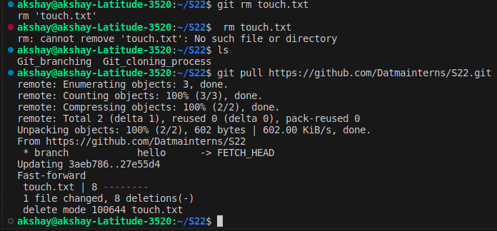
7. Pulling files -

Here, I deleted some files in git repo
and made changes and tried (ls) in
terminal and deleted same file in local
too and tried pulling
now the files are completely updated

8. Branching -

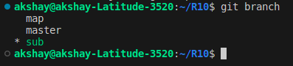

So here, I have created 2 other branches called sub and map
so whichever files I cloned to master are cloned to sub also and then here it is edited and pushed and things are done

command for creating new branch – git branch <branch_name>
command to switch to other branch – git checkout <branch_name>
To check which branch we are working on – git branch

9. Merging -

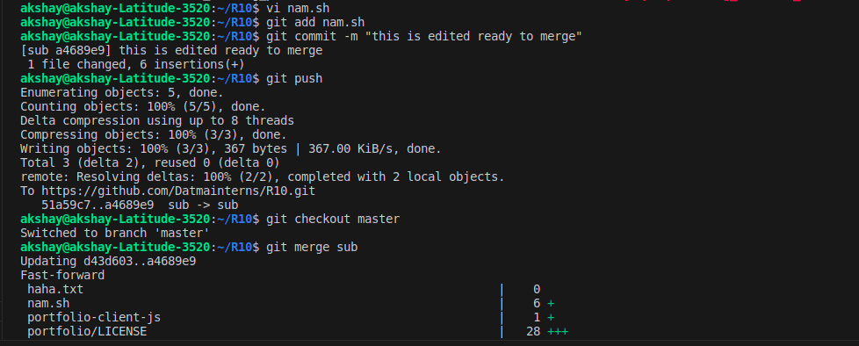
Here, I have edited the nam.sh file then,
git add nam.sh
git commit -m “this is ready to merge”
git push
git checkout master
git merge sub

First edit some file and git add the file and commit it with a message
then push the file, now merge come in action
switch branch from sub to master by git checkout master
and then git merge sub

now, you may get some conflicts in between so choose the proper option given
and resolve it

10. Git Stash

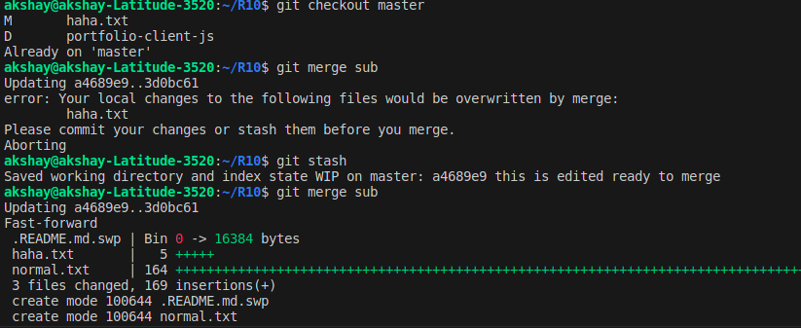
The Stashing concept is so simple the work is going on if you need to switch to other branch for different work without saving.
By stash we can pause the work done in the file

First edit some file then without commiting just checkout from sub to master
then try to merge you get this conflict saying please commit or stash
so by this git stash , your work will be saved
then try to merge

11. Fork



A fork in Git is simply a copy of an existing repository. A Git fork operation will create a completely new copy of the target repository. The developer who performs the fork will have complete control over the newly copied codebase.

